**Newark-IT Database Project Report**

CS-631-101

By:

Kijit Desai (kd227)

Alex Rodriguez(amr8)

1. Introduction

The following is the documentation of the database and web application project involving a company known as Newark-IT. Newark-IT is a web-based company that sells computers. Being a web-based company their market is often on a global scale. They wanted to create a database for clients, products, and sales transactions. After receiving the requirements, they were modeled into an Entity relationship diagram and then mapped into a logical database design for implementation. After creating and testing the database the front end web application was created. By linking the Newark-IT website with the database via PHP programming the website was able to successfully log products and other sales transactions. This also included customer information so that returning customers can log in to the database and get special offers based on their status with the website. By using this database system and web applications that were developed Newark-IT would continue to grow and become a successful website.

1. System Requirements

The following are the system requirements that are needed to be able to run the website for the database application for company “Newark-IT”.

User System Requirements:

* Windows XP or superior/ Mac OS X or superior
* Internet Browser
* Internet Access
* Sufficient Ram to run internet browser

This is the bare minimum needed to access the website and use the remote database server for customer transaction processing.

The following are applications that were used to complete the project:

MySQL- The database application that was used to store the data for Newark-IT. Queries are written in SQL and then the data is stored within the database that lets it be retrieved by the users.

PHP- This was used to access the database to create transaction and modify the database via the website

HTML- This was used to create the website to act as the front end for the database.

1. Database Design

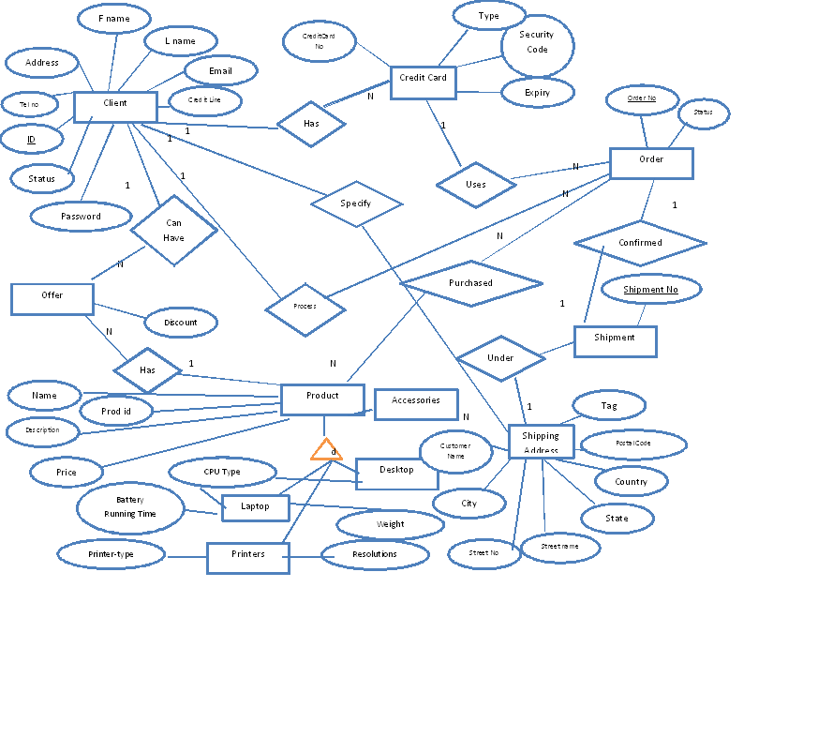

1. Database Mapping

Step 1: Strong Entities  
Client(`ClientID`, `FName`, `LName`, `Email`, `Password`, `Address`, `PhoneNumber`, `CreditLine`, `CreditStatus`)

Product (ProdID, Name, Description, Price)

Order(Order_no, Status)

Shipment( Shipment No, )

Step 2: Weak Entities

CreditCard (CreditCard_no, `Type`, `Security_Code`, `Expiry`)

Shipping_Address (Customer_name, Postal_code, `Country`, `State`, `Street_name`, `Street_no`, `City`)

Step 3: 1 to 1 Relationships

Shipment` (`Shipment_no`, `Tag`, `Customer_name`, `Postal_code`, `Order_no`)

Step 4: I to N Relationships

Order( Order_no, Status, CreditCard_no, ClientID, Prod_id)

Step 5: M to N Relationships

Offer(ClientID, Status, Prod_id, OfferPrice, Price, )

Purchased (Prod_id, Order_no)

Step 6: Multi-valued Attributes

There were none.

Step 7: Higher Order Relationship

There was none.

Step 8: Specialization

Laptop` (`Prod_id`, `Weight`, `CPU_type`, `Battery_life`)

Desktop` (`Prod_id`, `CPU_type`)

Printer` (`Resolution`, `Printer_type`, `Prod_id`)

Accessories` (`Prod_id`, `ProductName`)

Step 9: Aggregation

There is no aggregation

Final Logical Design:

Client(`ClientID`, `FName`, `LName`, `Email`, `Password`, `Address`, `PhoneNumber`, `CreditLine`, `CreditStatus`)

Product (ProdID, Name, Description, Price)

CreditCard (CreditCard_no, `Type`, `Security_Code`, `Expiry`)

Shipping_Address (Customer_name, Postal_code, `Country`, `State`, `Street_name`, `Street_no`, `City`)

Shipment` (`Shipment_no`, `Tag`, `Customer_name`, `Postal_code`, `Order_no`)

Order( Order_no, Status, CreditCard_no, ClientID, Prod_id)

Offer(ClientID, Status, Prod_id, OfferPrice, Price, )

Purchased (Prod_id, Order_no)

Laptop` (`Prod_id`, `Weight`, `CPU_type`, `Battery_life`)

Desktop` (`Prod_id`, `CPU_type`)

Printer` (`Resolution`, `Printer_type`, `Prod_id`)

Accessories` (`Prod_id`, `ProductName`)

1. Application Design

The application design was the same as others but there were some differences due to time constraints.

In addition a new table called cart was added to store user data for future purchases.

The following tables were used in the final database design:

Client(`ClientID`, `FName`, `LName`, `Email`, `Password`, `Address`, `PhoneNumber`, `CreditLine`, `CreditStatus`)

Product (ProdID, Name, Description, Price)

CreditCard (CreditCard_no, `Type`, `Security_Code`, `Expiry`)

Shipping_Address (Customer_name, Postal_code, `Country`, `State`, `Street_name`, `Street_no`, `City`)

Shipment` (`Shipment_no`, `Tag`, `Customer_name`, `Postal_code`, `Order_no`)

Order( Order_no, Status, CreditCard_no, ClientID, Prod_id)

Laptop` (`Prod_id`, `Weight`, `CPU_type`, `Battery_life`)

Desktop` (`Prod_id`, `CPU_type`)

Printer` (`Resolution`, `Printer_type`, `Prod_id`)

Accessories` (`Prod_id`, `ProductName`)

cart` (`cart_id`, `ClientID`, `Prod_id`)

User Manual:

The following is a guide on how to navigate the website for users new to e-commerce websites:

This is the first page of the website. A user needs to be logged in to see other pages of the website. Also, a user can use this page to register if not already a member.

Here an existing user can log in to the site or a new user can register.

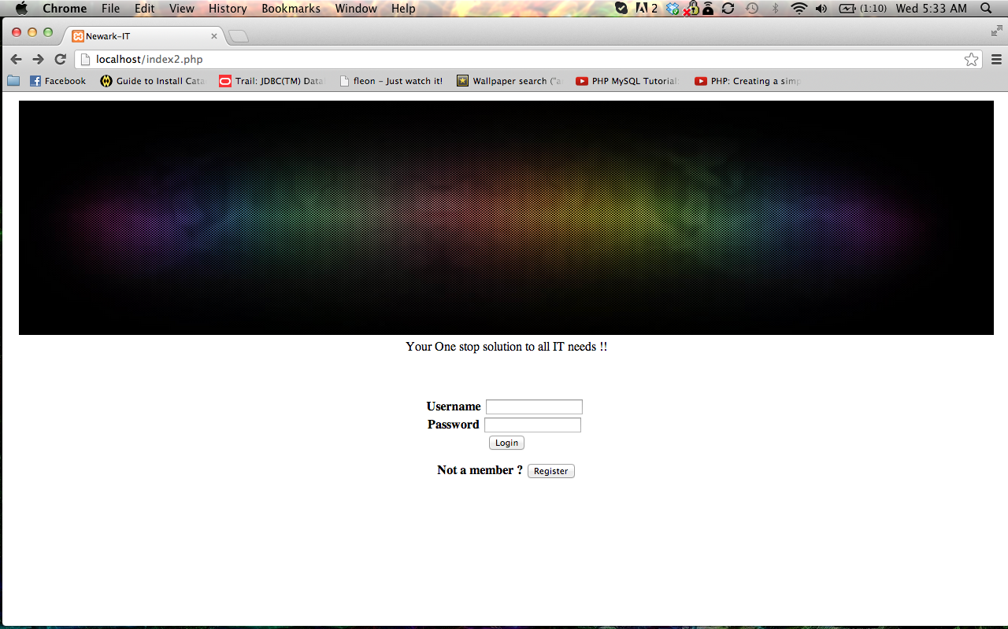

Registration Page:

For a new user please fill out all of the information in the text fields presented to register.

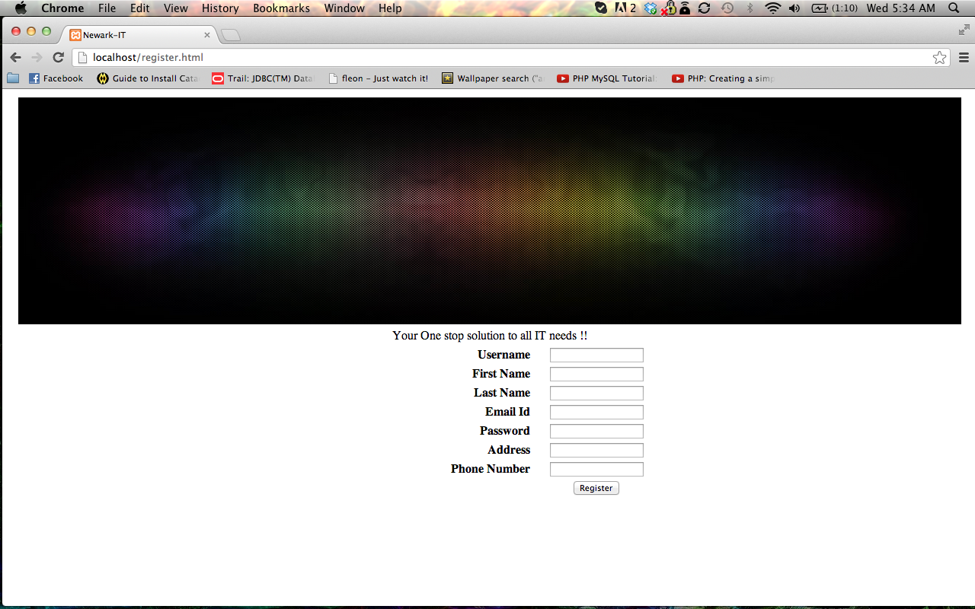

Logged in:

Once logged in, you should see a page like this. This means you are successfully logged in and ready to shop on the website:

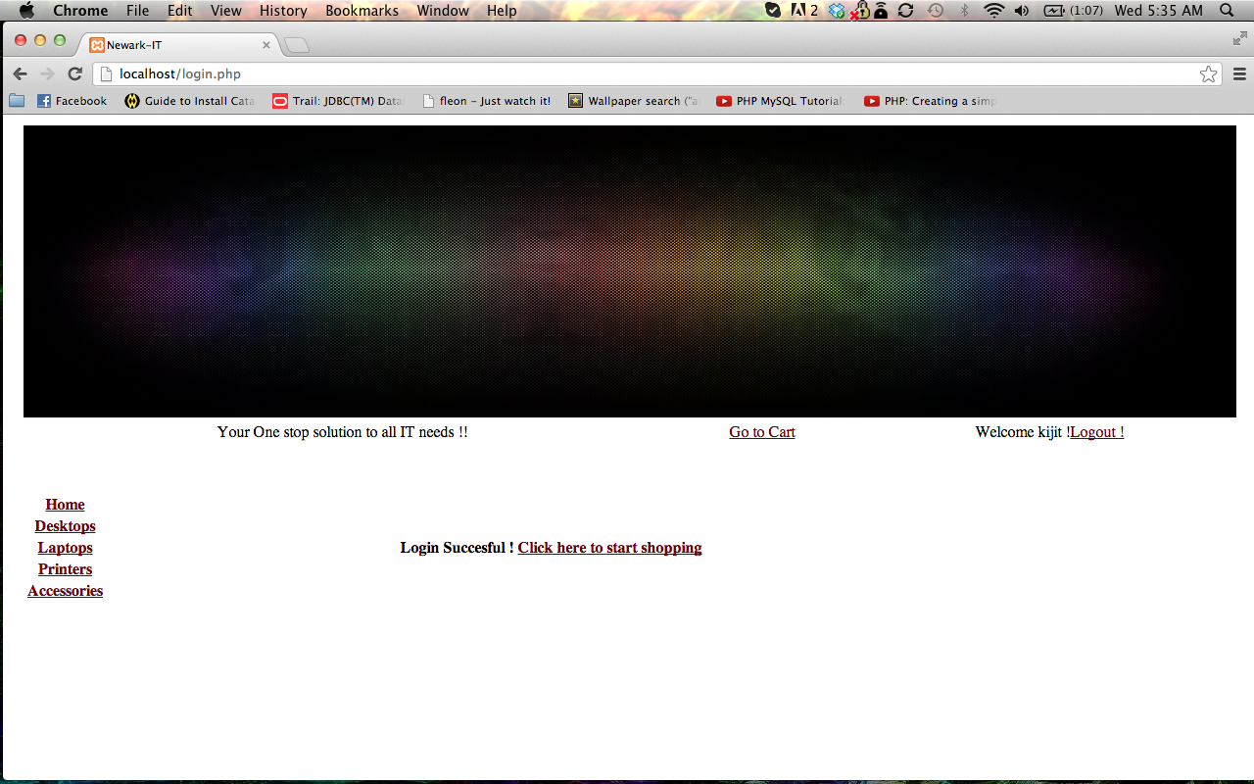

Accessories Page:

Here you can find accessories such as keyboards for your personal computer system.

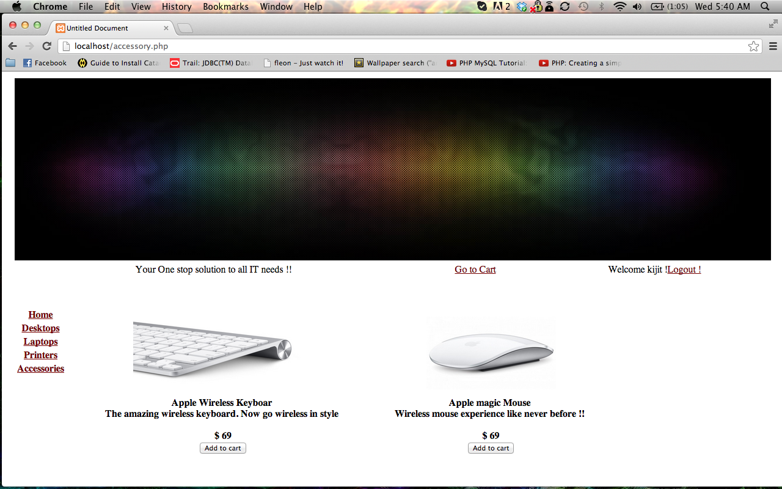

Desktop Page:

Here is where desktops are sold:

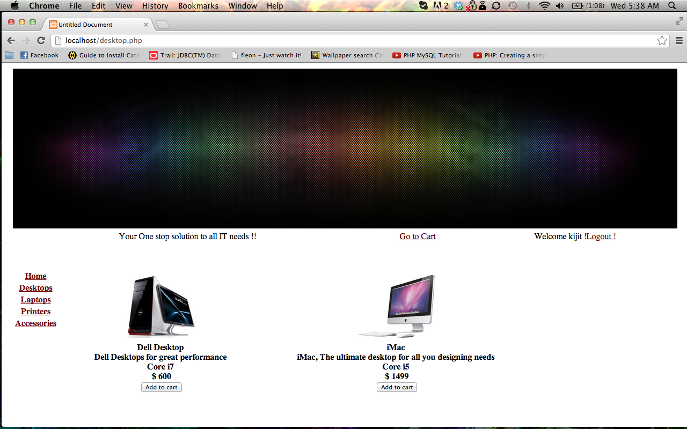

Laptop Page:

Laptops are sold on this page. Each has their own battery life and weight.

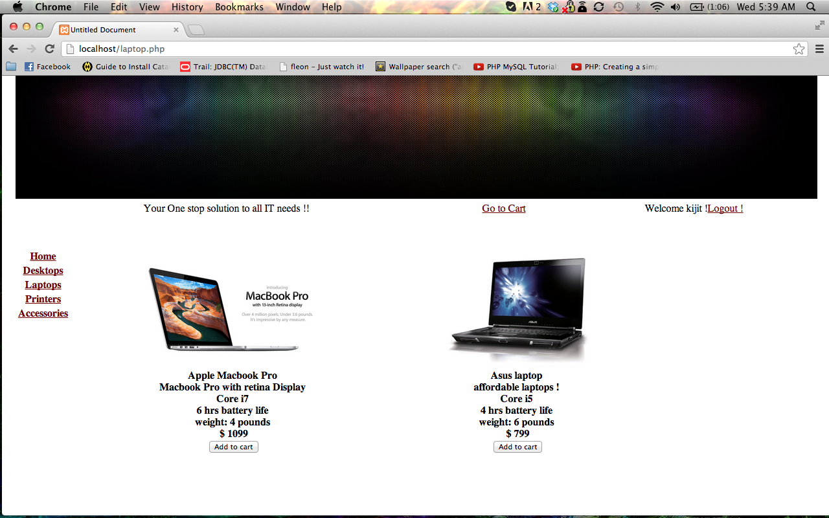

Printer Page:

This page shows printers for use with computers:

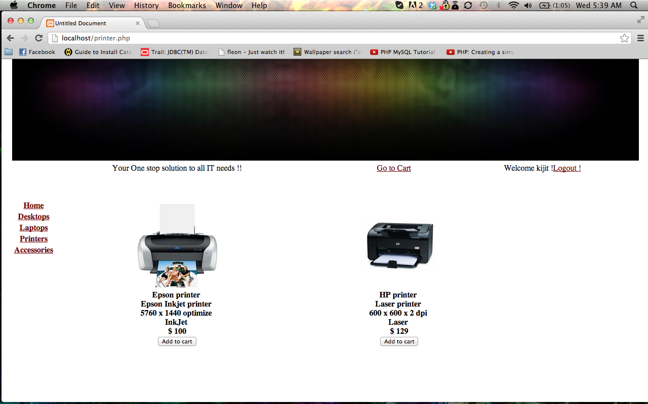

Cart Page:

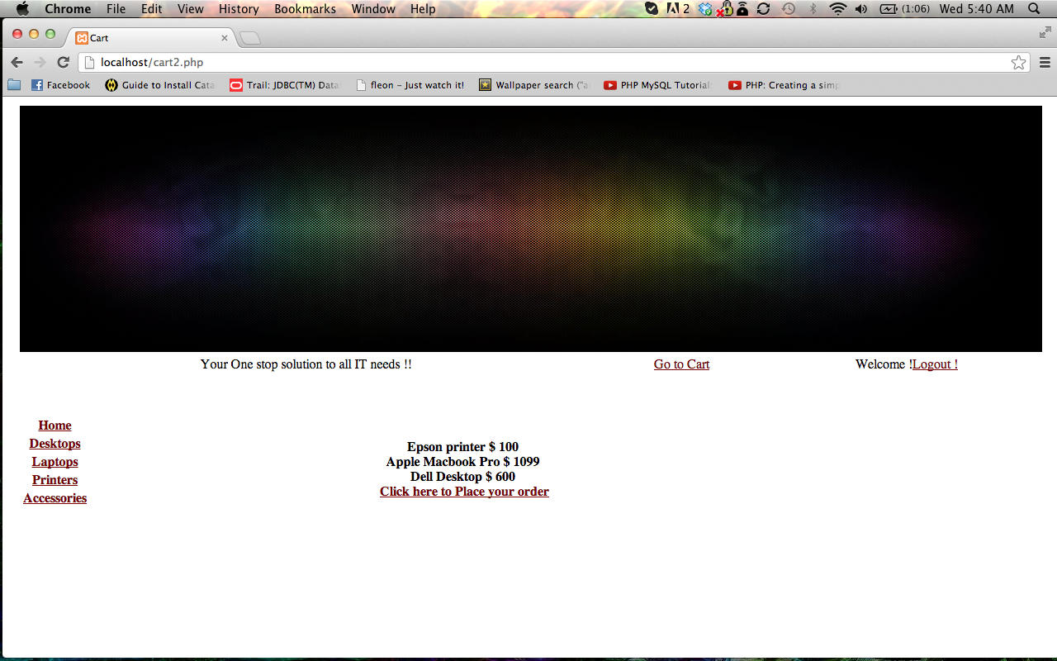

Confirming order:

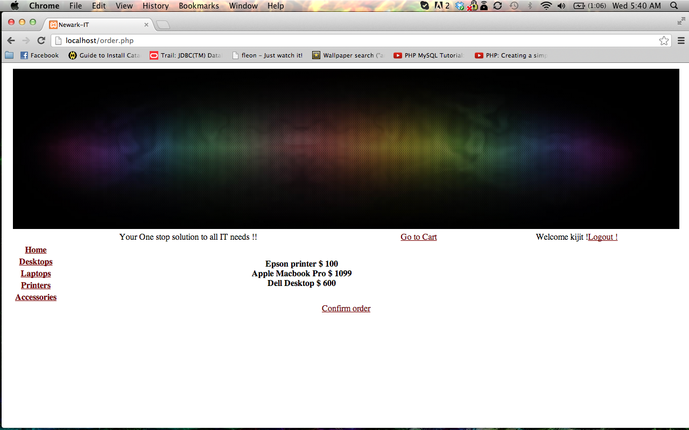

Credit Card:

Here is where one enters credit card information.

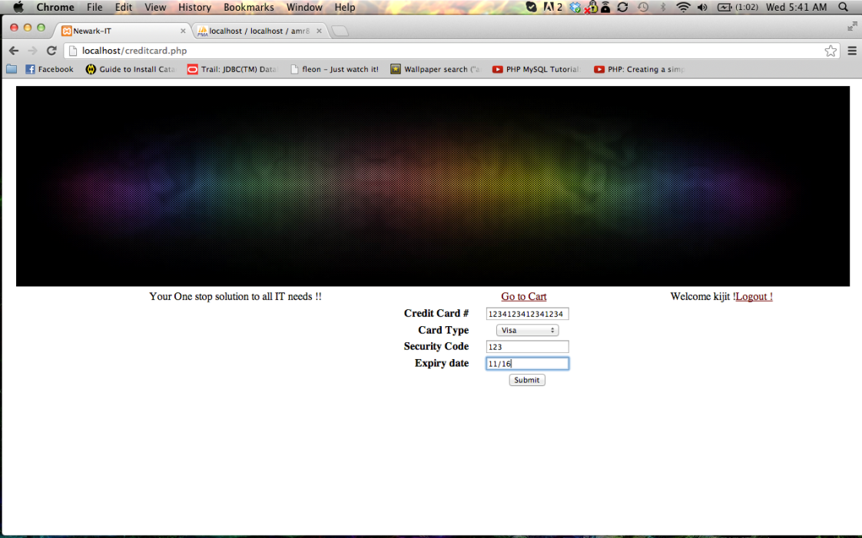

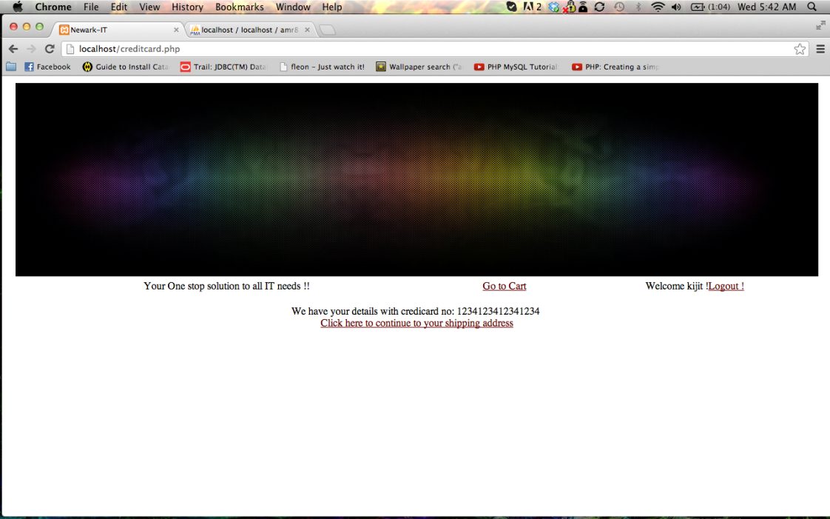

Shipping Address:

Enter the address you wish the produce would be shipped to.

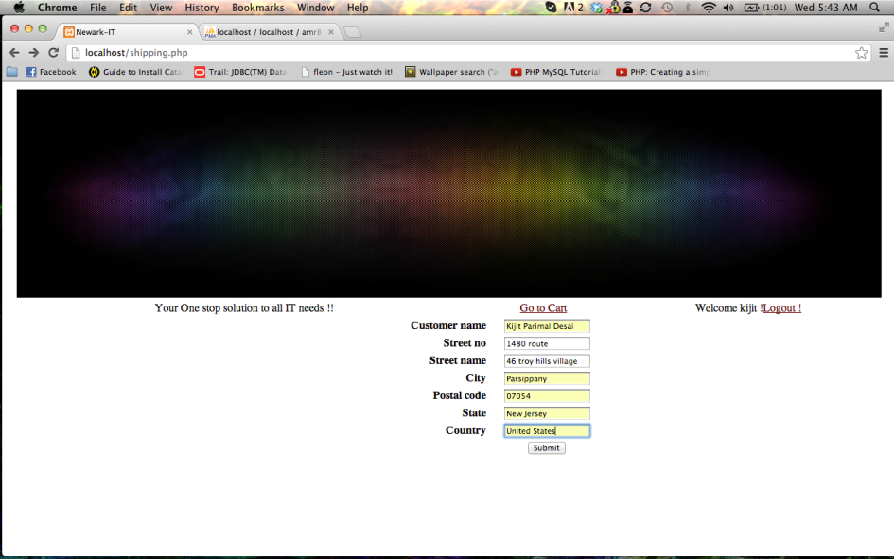

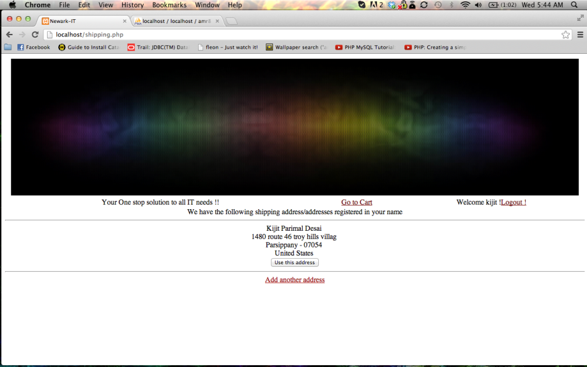

Final Confirmation:

After entering the necessary information your order is confirmed. You are given a shipment number to keep track of your order.

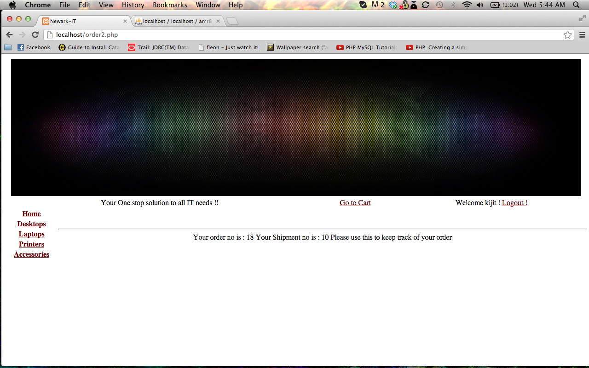

User profile

Here the profile can change the user details and track status of orders placed.

